EXPNO 2: CREATE A VIRTUAL MACHINE WITH 1 VCPU, 2GB RAM AND 15GB STORAGE DISK USING A TYPE 2 VIRTUALIZATION SOFTWARE

PROCEDURE:

1. the Google Cloud console, go to the **VM instances** page.
2. Choose In the stopped VM you want to modify from the VM list.
3. Click **Edit** at the top of the page.
4. In **Machine configuration**, select **General-purpose**.
5. In the **Machine type** section, select **Custom**.
6. Select the number of vCPUs you want.
7. To add extended memory, select **Extend memory** and then specify the amount of memory you want.
8. Save your changes.

Implimentation:

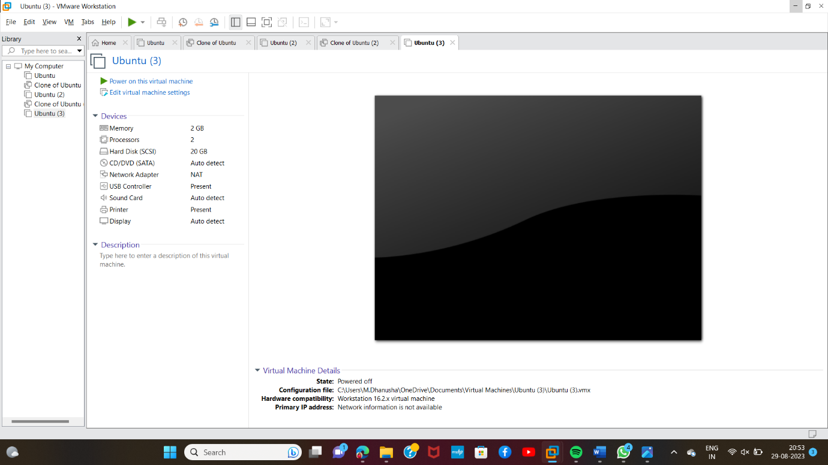

Result:Succsefully Implemnted VM Ware.